Button Game Project Packet

**Instructions**Make a game that...

**Extensions**

**Interaction**

Use the table below to plan out the interactive elements in your game. Think about how your program explains what is happening at different points in the game.

| **What action does the player make?** | **How does the program respond?** |
| --- | --- |
|  |  |
|  |  |
|  |  |
|  |  |

Design

Use the coordinate grid to draw the layout of the button game. Where are the score and instructions displayed? What would you like the button and the background to look like?

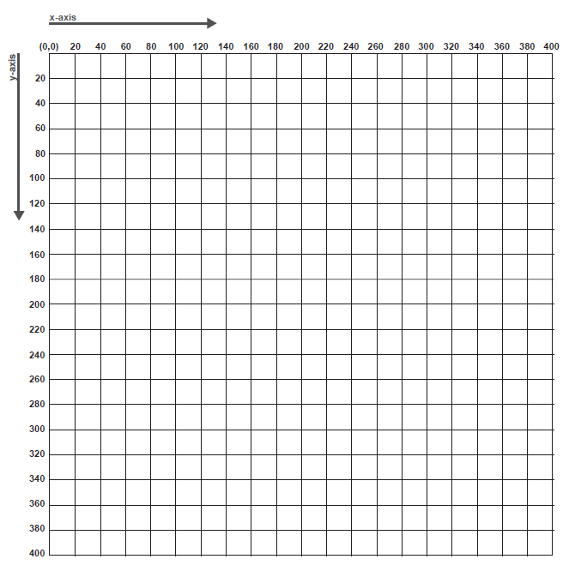

Plan

**Images**

List any images you plan to use and cite their sources below:

**Pseudocode**

What steps will you take to implement this idea?

Process

**Create**

Use the planning section to begin coding. For each game element you try to create in p5, fill out the table below:

| **Step #** | **What were you trying to do?** | **Did it work?**  **(Y/N)** | **If no, what happened instead?** |
| --- | --- | --- | --- |
|  |  |  |  |
|  |  |  |  |
|  |  |  |  |
|  |  |  |  |
|  |  |  |  |
|  |  |  |  |
|  |  |  |  |
|  |  |  |  |
|  |  |  |  |
|  |  |  |  |
|  |  |  |  |

**Test/Evaluate**

Have a peer test out your game, and use their feedback to help answer the questions below.

1. Does the game meet the criteria in the rubric? Explain.

2. What do you like about the game? Name the parts that are successful:

3. What parts of the game don’t work or are confusing?

4. If your design doesn’t meet the criteria in the rubric, what do you need to add? If it does meet the criteria, what can be added to improve the game design?

**Improve**

List what you need to change to meet the rubric’s criteria. If you have met the criteria, choose 1 - 3 game design aspects to improve:

Plan/Pseudocode:

Peer Feedback

| **Name** | **What do you really like about the game?** |
| --- | --- |
|  |  |
|  |  |
|  |  |

| **Name** | **What would you improve? Give a suggestion.** |
| --- | --- |
|  |  |
|  |  |
|  |  |

| **Name** | **What is one question you have about the project?** |
| --- | --- |
|  |  |
|  |  |
|  |  |

Self-Reflection

1. What were the most successful parts of your game? Review the **Peer Feedback** sheet to help you answer.

2. What parts of your game could be improved? Review the **Peer Feedback** sheet to help you answer.

3. When did you get stuck? What strategies did you use to get unstuck?

4. What is one thing you learned that you didn’t know before you began this project?